**E-Commerce Website**

**Overview:**  
This project is an end-to-end e-commerce website focused on selling smartphones. It’s built using React for UI development, React Router for seamless page navigation, Context API with useReducer for global state management, and Tailwind CSS for styling and responsiveness. The design emphasizes a modern, sleek look with interactive elements such as hover effects, toast notifications, and a dynamic hero section.

**1.Home Page**

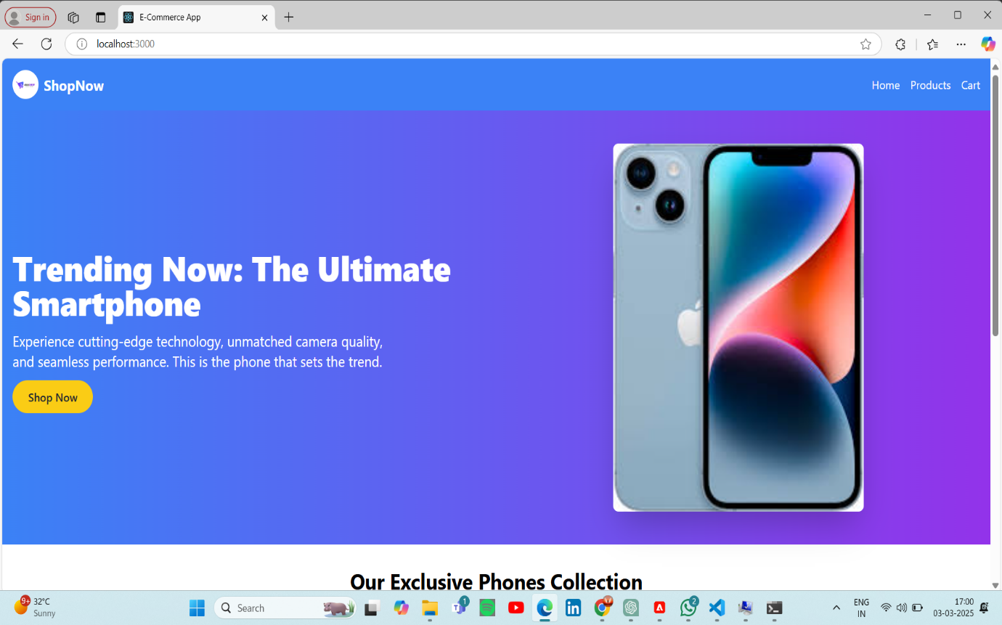

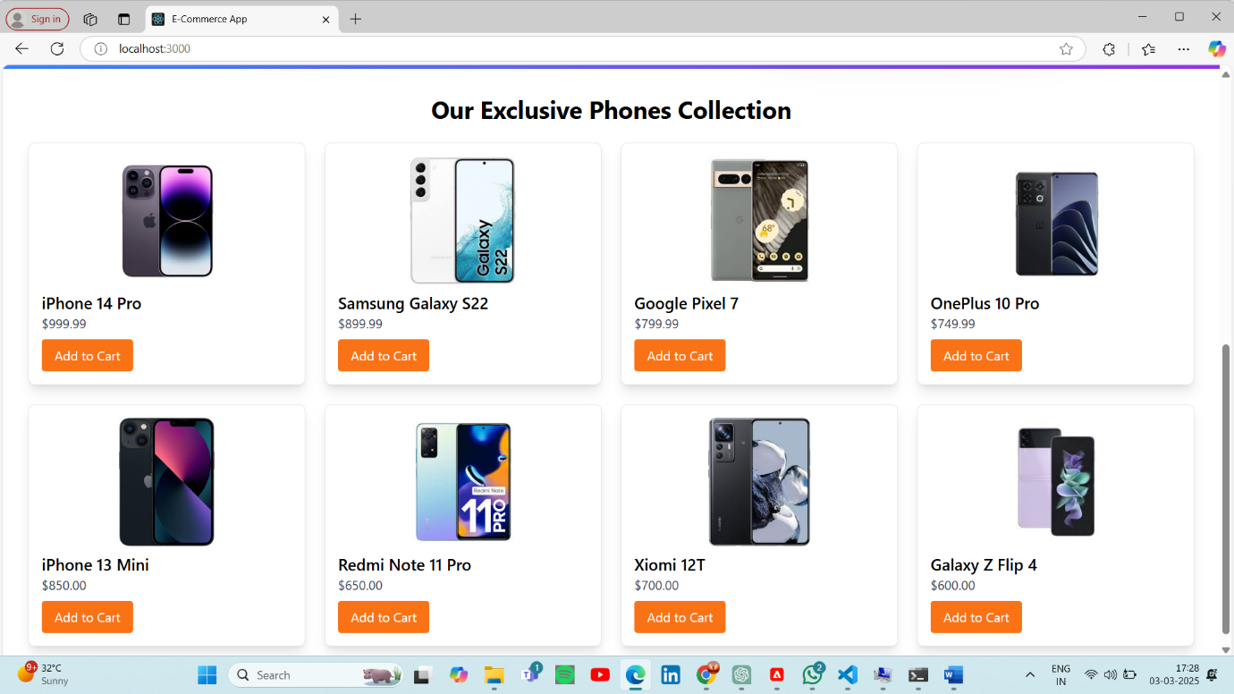

**2.Products Page**

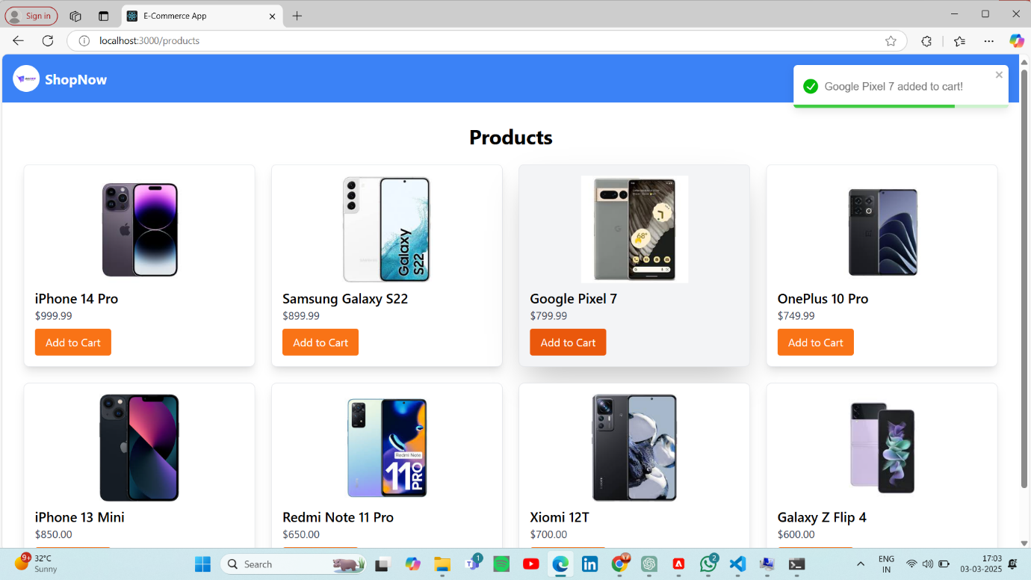

**3.Cart Page**

